**Impact-Spot Unity Installation Guide**

Table of Contents

* Minimum Requirements
* Setting up Meta Quest for installation
* Setting up Side-Quest for installation
* How to Install
* Testing and setting up
* Links to required Packages

*Minimum Requirements*

The checklist of the minimum requirements for setting up and running the app is as follows.

1. PC/Laptop to install from (Windows/MacOS)
2. (USB A to C) or (USB C Gen 3 to USB C)
3. Software packages of the Occulus App and SideQuest
4. Meta Quest 2
5. A SmartPhone with Meta Account
6. Downloading the App

Setting Up Meta Quest and Side-Quest for Installation

Once you have set up your quest and logged in with your Meta you can then proceed with setting up your quest for the installation.

To install the app, the quest must have several options enabled and Side-Quest installed on your PC/Laptop. Check the guide in Link 1 to see how to set up the quest for external installations. (Includes the installation for Side-Quest)

How to install

Download the app via Link 2 and save it in an easily accessible folder on your PC/Laptop.

Once you have Side-Quest installed and the app downloaded, the installation of the app is relatively simple. When you have the Quest successfully connected to your PC/Laptop(You can check if it’s connected by seeing if the dot at the top left is green or red, green means connected and vice versa),

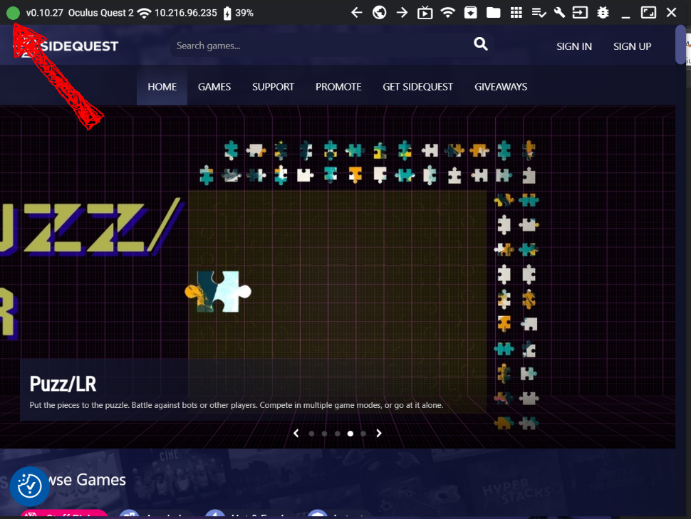

simply open the Side-Quest app on your Laptop/PC and click this button:

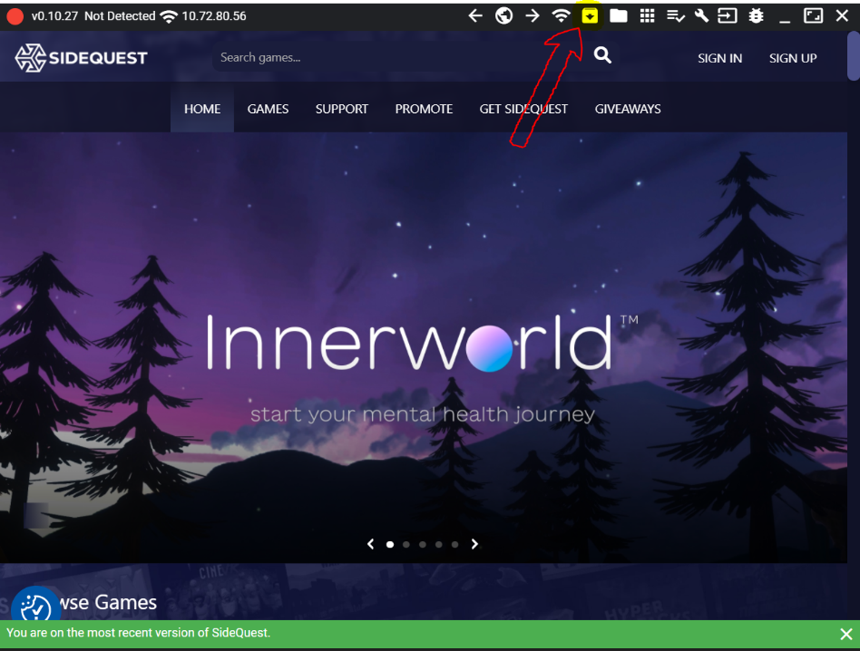

Clicking on that button will result in a popup, to pick the app that needs to be installed, navigate to the location where you have downloaded and saved the app and select it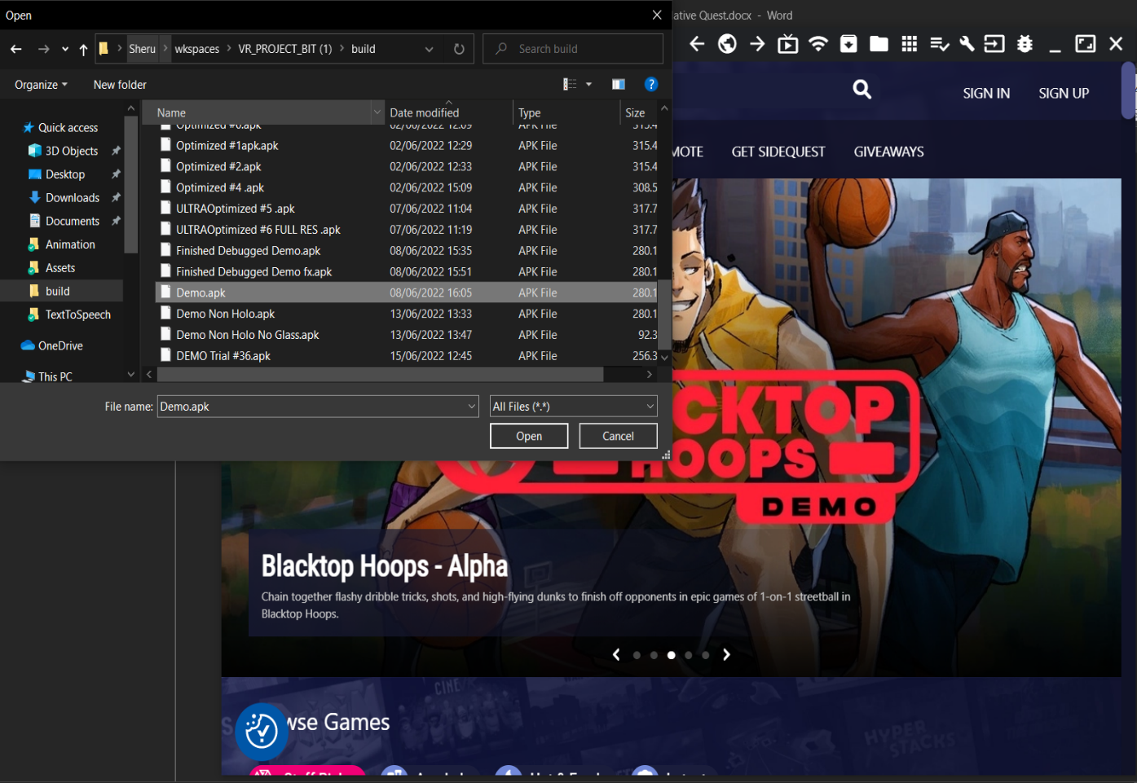

If the installation was successful you will receive a message at the bottom of the screen like this, if you don't see this then try again.

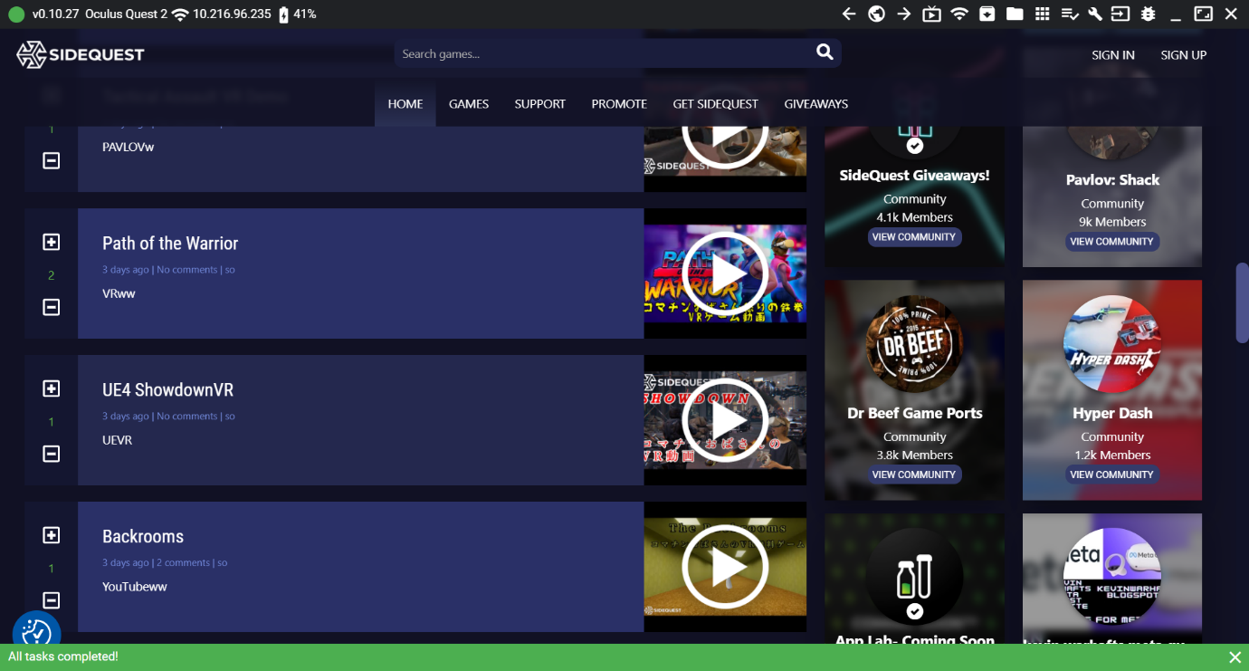

LINKS

* [Link 1](https://sidequestvr.com/setup-howto)